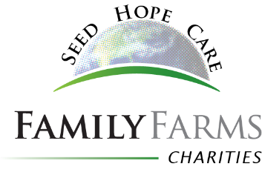
Internship Application

Applications for 2018 internships are due February 1, 2018.

Name of Applicant:

Farm Name:

Farm Location/Address:

Phone: Email:

Applicant Age:

List your geographic preference for an internship:

Describe the type of farm you would most like to work on – (size, crops, irrigation, organics, other special interests):

Describe the area of the farm you are most interested in working during the internship:

Describe the time(s) of the year would you prefer the internship:

Describe the length of your preferred internship:

Are you willing to work at least 40 hours per week for minimum wage? If no, please describe:

Are you willing to live in the same home as your host family or in the home of a relative or neighbor? In a hotel? In an apartment or home of your own?

Describe your skills and experiences that will make you a valuable intern:

Are you willing to share your skills and experiences with your host farm, even if in an area different than your internship? For example, if you will be driving combine during harvest, are you willing to help with some IT needs while there if you are a gifted techie?) Please explain:

List anything else you want the selection committee to know:

