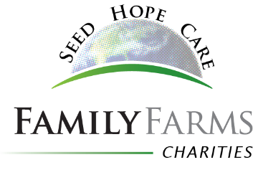
Host Farm Application

Applications for 2018 internships are due February 1, 2018.

Farm Name:

Farm Location/Address:

Phone: Email:

Describe your farm, crops, number of employees, irrigation, organics, other special interests, anything

the potential intern would want to know:

Describe the area of your farm in which you would like to host an Intern (Operations/Office/HR/Technology/Finance, etc):

Describe the time(s) of the year would you prefer to host an Intern:

Describe the length of your preferred internship (minimum 1 month, max 1 year):

Are you willing to pay the intern minimum wage for at least 40 hours per week? If no, please

describe:

Are you able to supply a mentor to ensure the intern has a valuable internship experience? Please explain who and describe why they would be a good mentor:

Are you willing and able to supply housing and at least one meal per day to the Intern? (FamilyFarms Charities will provide $350/month to Host Farm.) Please describe your housing arrangements/possibilities (In your home, a neighbor, an apartment, etc.) :

Describe any special skills or experiences you would look for in an intern:

All Interns must be at least 18. Do you have any preferred age category?

List anything else you want the selection committee to know:

